**Problem 1:**

***-Critique 1***

1. What data is represented in this visualization?

The visualization shows the total change in nonfarm payrolls from the previous month, between 2015 and May 2020. It shows that the total change in nonfarm payrolls has been minimal between January 2015 and January 2020. During this period, there seems to be either a small increase or small decrease in nonfarm payrolls from the previous month. In 2020, nonfarm payrolls experience a significant decrease from the previous month. The largest decrease in nonfarm payrolls occurs in April 2020 with a decrease of -20.7 M. The largest increase in nonfarm payrolls occurs the following month with a gain of 2.5 M. The data source is the Bureau of Labor Statistics.

2. What questions does the visualization answer?

The visualization answers questions about the job market in the last five years. It tells us if companies were mostly hiring nonfarm employees or mostly releasing nonfarm employees between January 2015 and May 2020. As a result, this visualization provides an indicator to how unemployment is changing. The visualization can be used as an indicator for the state of the economy. If more nonfarm employees are being added to the payrolls, this can mean that the majority of companies are performing well and that the economy is good.

3. Describe one aspect of the visualization that is effective.

The visualization uses scale to its advantage. The eye is drawn to April 2020 because it is drastically lower than all of the other points. As a result, the visualization effectively communicates the message that April 2020 experienced the highest amount of job losses.

4. Describe one aspect of the visualization that is not effective.

The visualization does effectively communicate when the decrease began. The chart does not include months on its x axis, which makes it difficult to determine when in 2020 did people begin to lose their jobs.

5. Why do you like/dislike the visualization?

Overall, I do not like the visualization because of its vague labelling and misleading presentation. I did not like that the upper bound of the y-axis is below the job gain of, “May 2020.” In my mind, the, “+2.5M,” data point would look relatively smaller if the upper limit of the y-axis was slightly above +2.5M. Furthermore, the visualization might be interpreted in a way that suggests jobs have dramatically improved between April 2020 and May 2020. The chart does not include months on its x axis. This makes it difficult to determine the month in 2020, that saw large amounts of people lose their jobs. I would have preferred if the visualization gave more information about the region it is analyzing. Initially, I was not sure if the visualization was solely talking about the United States. Once I read the source at the bottom of the figure I realized that the data is most likely an analysis of job losses and gains in the United States.

There are some aspects that I like about the visualization. It does a good job of displaying the dramatic change in total nonfarm payrolls in April 2020. Placing the exact number of jobs lost next to the minimum in the plot drew a lot of attention that month.

***-Redesign 1:***

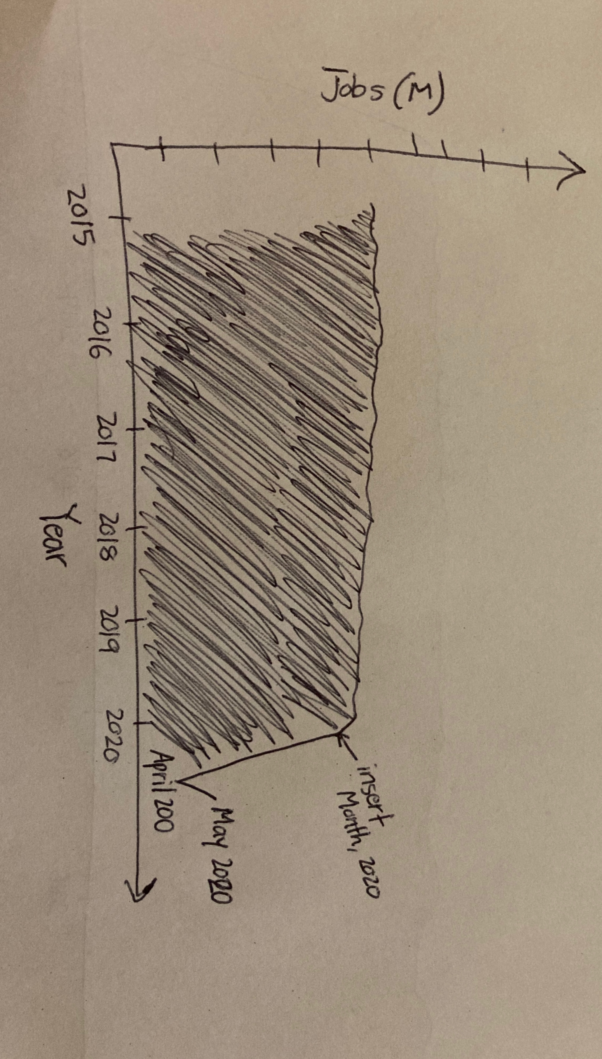

**Redesign description:**

The redesign is displaying the total amount of jobs in the United States between 2015 and May 2020. The design fills in everything below the maximum to aid the visibility of the maximum value. The advantage of the redesign is that it eliminates the confusion that might occur if the viewer does not pay close attention to the original design. When looking at the redesign, the viewer will not make the incorrect interpretation that May 2020 fixed the overall job situation. Therefore, the redesign provides a more accurate representation of the overall job situation in May 2020, while maintaining its presentation of job losses in April 2020. In addition, the redesign will label the first month that experienced a noticeable drop in jobs in 2020. This will inform the viewer about the first instance of large scale job loss that occurred during 2020.

**Problem 2:**

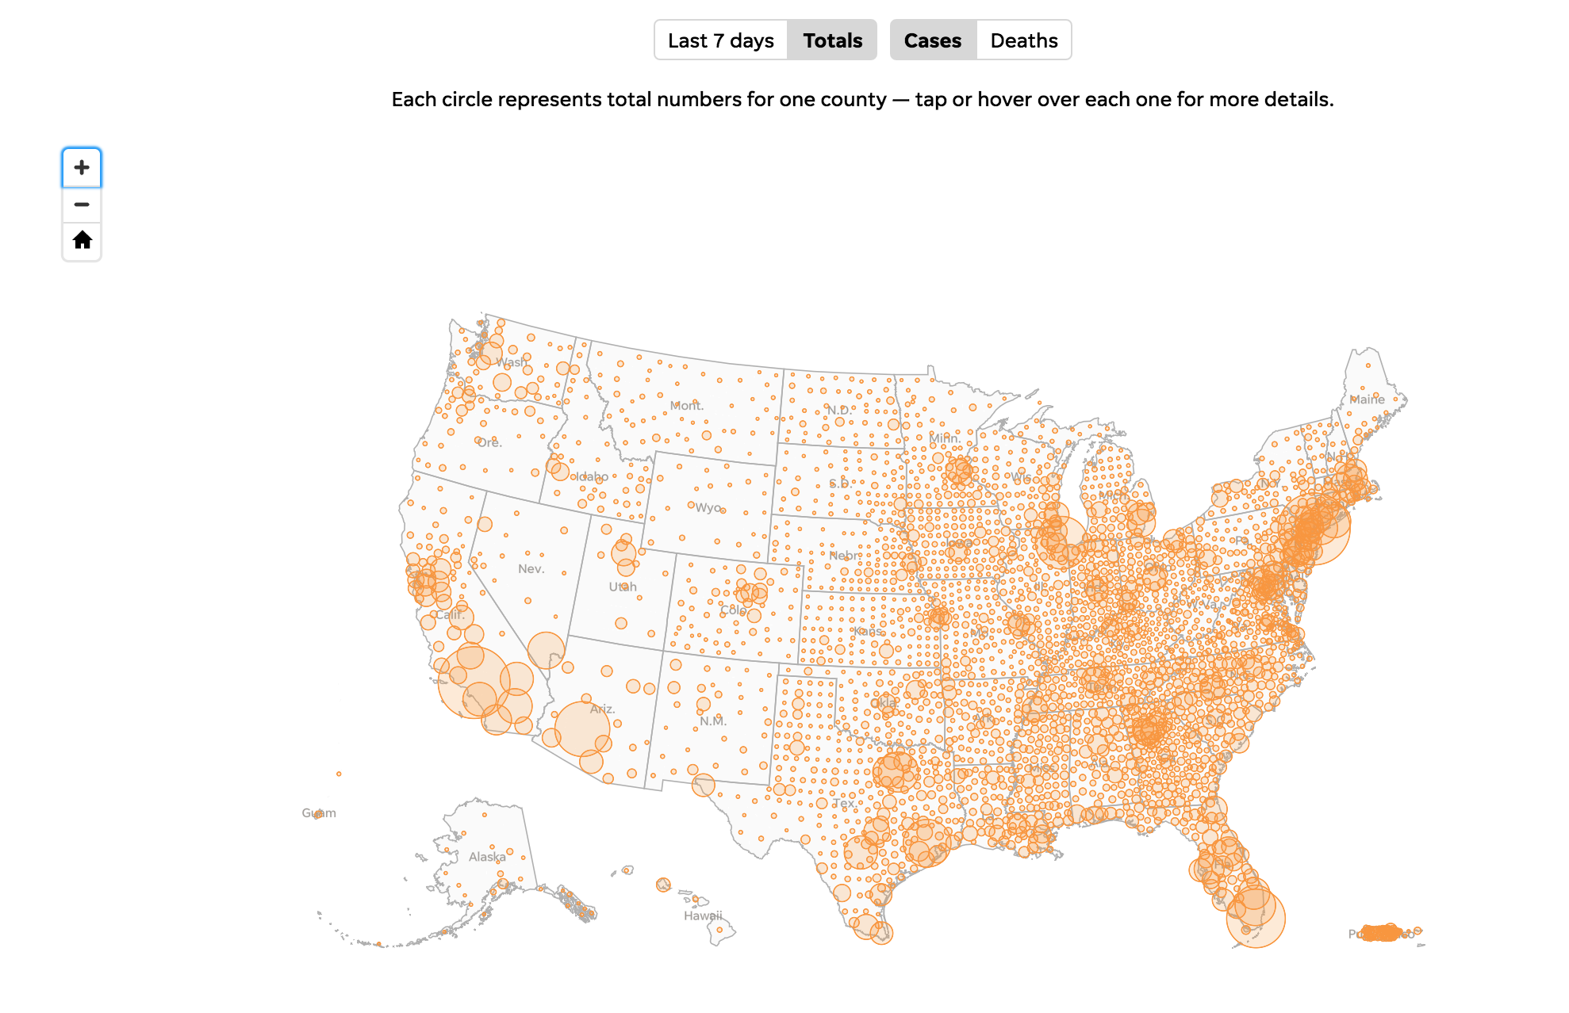

<https://www.usatoday.com/in-depth/graphics/2020/03/10/us-coronavirus-map-tracking-united-states-outbreak/4945223002/>

***-Critique 2***

1. What data is represented in this visualization?

This visualization is an interactive visualization that displays the amount of coronavirus cases in counties of every state in the United States, alongside the territory of Puerto Rico. The size of the each circle represents the total number of cases for each county. The interactive feature allows the viewer to tap each circle and view the exact number of total cases, total deaths, and new cases in the last seven days of that selected county. The visualization shows that there are large amounts of cases in counties with large metropolitan cities, such as Los Angeles County and New York County. In addition, the visualization shows the small amount of cases in lesser populated areas across the western United States.

2. What questions does the visualization answer?

The visualization answers questions about the coronavirus pandemic in the United States. The visualization provides an overview of which regions of the United States are most affected by the pandemic. It can provide answers to how many total cases and deaths a specific county on the map has. In addition, the visualization provides answers to the rate of cases per 100000 people and the amount of new cases in the past seven days for certain counties.

3. Describe one aspect of the visualization that is effective.

The scale of the circles is effective in distinguishing between the areas with large amounts of cases from areas with low amounts of cases. The eye is drawn to the areas with large amount of cases. The viewer will probably want to avoid regions where the virus is prevalent, and this visualization informs the viewer where in the country the virus is widespread.

4. Describe one aspect of the visualization that is not effective.

One aspect of the visualization that is not effective is that it provides too much county data for some states. For example, the state of Maryland is overwhelmed with a large amount of circles. The viewer cannot distinguish the different counties from one another because there are a lot of circles overlapping each other. The viewer is unable to determine which counties are performing better or worse in Maryland.

5. Why do you like/dislike the visualization?

I think that the visualization provides a good overview of the United States, but does not completely satisfy the viewer on a state level. As mentioned before, some states have too many overlapping circles. The overlapping circles make it difficult to select counties within that state. As a result, the viewer has to struggle in order to determine which counties within the selected state have more cases. On the other hand, the state of Utah does not have adequate county data. This state has broad groupings of counties such as, “southwest Utah.” Furthermore, it is unclear which counties fall under each grouping. Viewers who are not familiar with the state of Utah might be under the impression that Utah only has five counties south of Salt Lake City. The inconsistency among the states may lead the viewer to make incorrect conclusions about the coronavirus situation in Utah.

***-Redesign 2:***

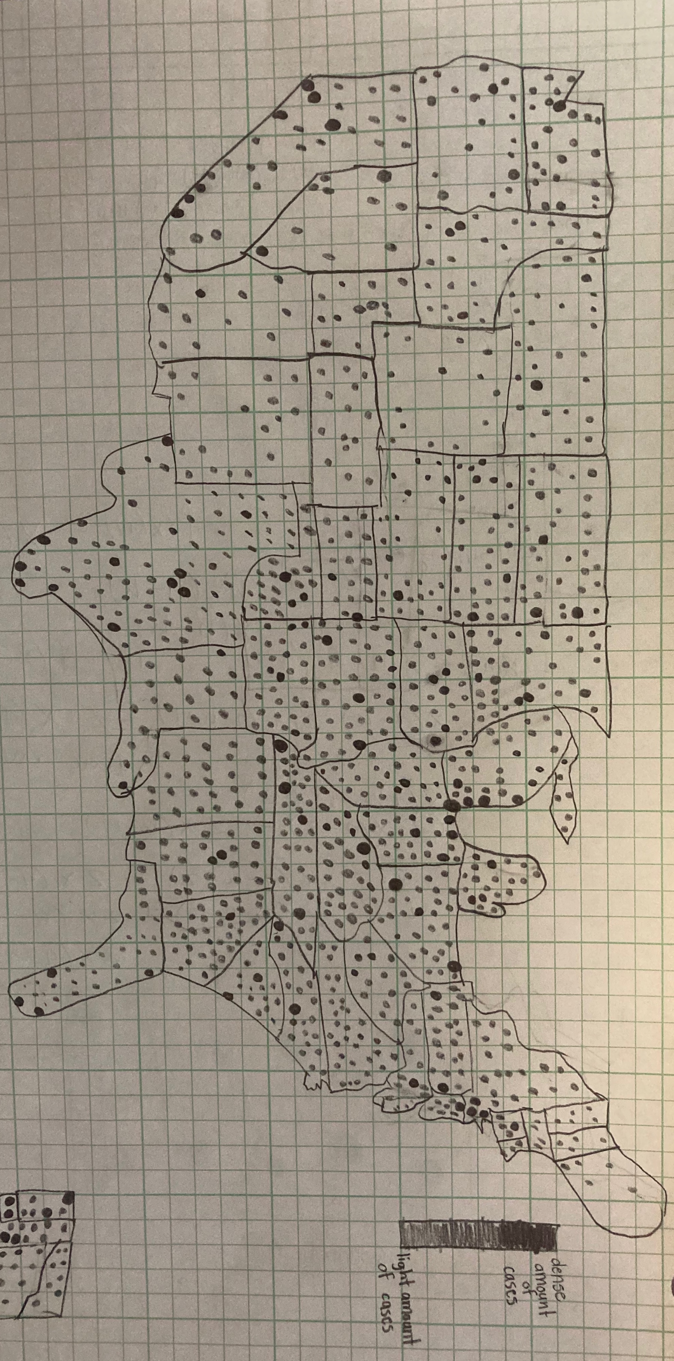

Figure 1: This figure displays the main view of redesigned visualization.

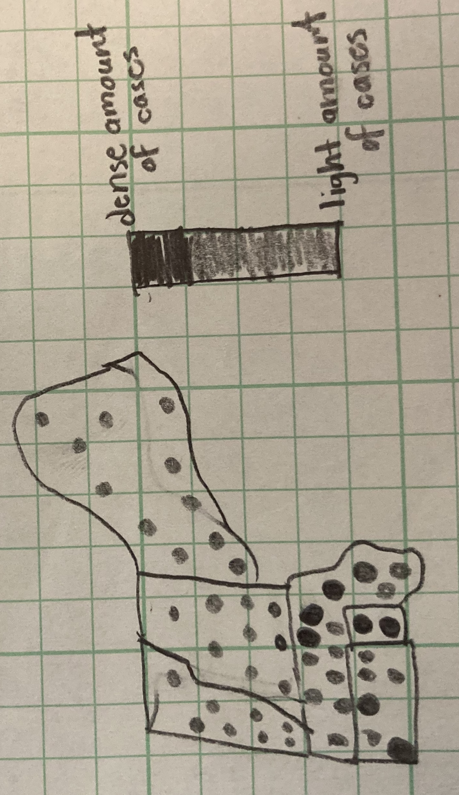

Figure 2: This figure displays one region that may be selected in the redesign.

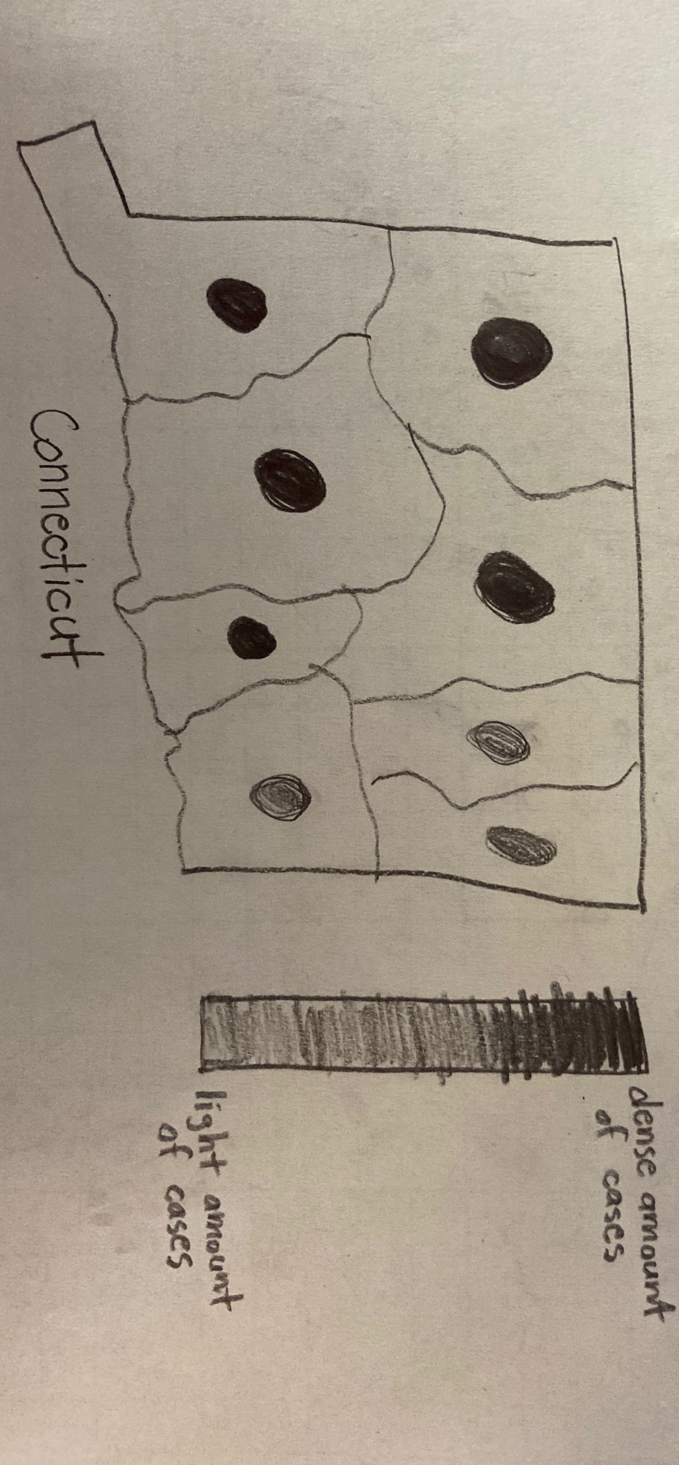

Figure 3: This figure displays the state that may be selected in the redesign.

Redesign description:

The redesign will initially provide an overview of the country as shown Figure 1. The circles of the original design will be replaced by dots that will be placed in each county. The counties with more cases will have a dot with a darker shade of red, while the counties with less cases will have a dot with a lighter shade of red. The size of the dot will be proportional to the size of the county. The viewer will still have the ability to tap on a given dot and view the exact number of total cases, total deaths, and new cases in the last seven days of the selected county. This design will help distinguish counties from one another by removing the problem of overlapping circles present in the first design. Furthermore, the visualization will provide the viewer with the option of bringing an entire region of the United States to the forefront, as shown by Figure 2. In the “region view,” the viewer will still have the ability to tap on a given dot and view detailed statistics on that county. Additionally, the viewer will have the ability to press on a specific state when viewing a specific region, as shown in Figure 3. The “state view,” will use same color scheme as the other views. This visualization will present data on every county, which is a claim that the original design does not satisfy. In addition, it allows the viewer to visually compare cases in areas of the county that are more difficult to observe on the countrywide map.